# 

Database Administrator

Processes and Procedures

Information Technology

Table of Contents: Database Administrator

Section1. Database Administrator Processes.................................................................1

1-2. Develop Maintenance Plans.........................................................................................................2

1-3. Schedule Tasks to Reboot all Servers............................................................................................3

1-4. Run Standard SQL Server Backups...........................................................................................3

1-5. Manage Transfer of Digitized Documents using COLD....................................................................3

1-6. Daily Verification of DTS Packages....................................................................................................4

1-7. Other Responsibilities........................................................................................................................4

Section 2. Procedures......................................................................................................6

2-1. “Kill” a Blocking Process...............................................................................................................1

2-2. Viewing Daily Maintenance Jobs.......................................................................................................7

2-3. Creating a New DB Maintenance Plan............................................................................................10

2-4. Creating a New Database................................................................................................................11

2-5. Register a SQL Server in Enterprise................................................................................................12

2-6. Transferring Scanned Documents through a Vortex Configuration File........................................12

2-7. OutlookSoft 5: Setting the System to Available.............................................................................. 17

2-8. Recovering Vortex Batches..............................................................................................................22

# **Section 1. Database Administrator**

Application Development

This document serves as a written record of the functions of the Database Administrator in the IT department of Columbia College Chicago. This includes a summary of responsibilities, procedures, and additional information germane to the position.

## Summary

The Database Administrator maintains all the SQL servers, the applications under those servers, and any auxiliary servers. These servers include the PeopleSoft servers, the two largest servers utilized by the Human Resources and the Accounting departments. The DB Administrator also transfers digitized documents in COLD, a feature of the Feith Document Database.

## Responsibilities

Typical responsibilities include:

* Database maintenance
* Developing maintenance plans for the databases
* Scheduling tasks to reboot all servers
* Running Standard SQL server backups
* Managing the transfer of digitized documents using COLD
* Verifying SSIS Packages daily
* Occasionally writing reports for a database

### 1-1. Database Maintenance

The Database Administrator maintains all databases under his control by ensuring that they are running properly and all scheduled tasks, such as maintenance plans, operate correctly. Part of his maintenance responsibility includes researching and implementing solutions for changes that may affect database performance. For example, the 2007 change in Daylight Savings Time (DST) required additional time and consideration.

### PeopleSoft Servers

The Database Administrator also manages the PeopleSoft Servers. Maintaining these servers only takes up a small amount of the administrator’s daily tasks. However, the involved tasks must be observed daily. Every day, the Database Administrator checks to see if the maintenance plans ran successfully. Failed maintenance plan jobs alert the Database Administrator via email.

### When There Are Problems

There are occasions when users (e.g., HR or Accounting) do something that cause the servers to lock up. For example, users may try logging in with the same login information to multiple workstations. When this happens, users contact the Database Administrator.

For information on the operational aspects of the PeopleSoft Servers, contact [both Bobs]. The Database Administrator does not work on the operational aspects of the PeopleSoft Servers.

When users experiences problems such as lockups, they contact the Database Administrator via email or telephone for resolution.

### Server Information

Currently, three (3) PeopleSoft servers exist. Two of these servers are active. They function for Human Resources and the Accounting department. The third server is a testing server.

#### Human Resources Server (HRDB)

Human Resources have their own server, with one production database, DINERO.

#### Accounting Server (PS9DB)

The Accounting department distributes its server amongst all the department’s functions with one production database, ALLEGRO.

#### Testing Server (FOLIODB)

This server is utilized as a testing area where people “play” with “stuff” before putting it in production. There are four test databases each for Human Resources and Accounting.

#### 1-2. Develop Maintenance Plans

The Database Administrator develops maintenance plans for databases by running a maintenance plan wizard, which comprises of a series of screens. Within these screens, the administrator selects the appropriate functions and databases. The maintenance plans also set up jobs in the SQL scheduler because the SQL server system has its own scheduler. Once these plans are set up, they run four functions on their own (see the functions below).

The Database Administrator utilizes a Maintenance Plan Wizard to execute four functions. Once he sets up the jobs, the following functions automatically run as scheduled by him:

• **Database backup** (once per day, daily) 10:00p.m.

• **Database integrity check** (always before backup)

o Runs database integrity check for both servers once per night before running backup

• **Transaction log backup** (hourly)

o Runs transaction log backup hourly (6 a.m. – 10 p.m.)

o Afterwards, conducts full backup once per night

Note: If a disaster happens, a full backup of the previous night exists. The hourly transaction log backups are also available to restore each backup. Those backups aren’t removed off tape. There is a potential loss if physical damage happens to the machine. There is a need to investigate if the server must be removed to another site to obtain the full state of the database in case of emergency.

• **Rebuild indexes** (once per week)

**1-3. Schedule Tasks to Reboot All Servers**

The DBA schedules tasks to reboot all servers when a new server comes in. Once he sets up the reboot, the task runs by itself for all servers. The reboot typically takes place on Sunday nights.

**1-4. Run Standard SQL Server Backups**

The DBA runs the standard SQL Server backups. Billy Cole runs backups plus full server backups to tape.

**1-5. Manage Transfer of Digitized Documents Using COLD**

COLD is a feature of the Feith Document Database, a production system that is a work in progress. More departments are continuously added.

COLD allows administrators to transfer scanned documents in large batches. These documents include, but are not limited to:

* Admissions documents (e.g., school transcripts and essays)
* Pledge documents from donors
* Columbia College school records
* Student loan applications and approvals
* Provost office documents

COLD serves as a digital storage unit to facilitate retrieving documents. The purpose of COLD is to eliminate paper and manage documents electronically.

The IT department has a contract with Microsystems, Inc. to take received paper documents and scan them into graphical files.

**Status of Conversions**

There are always documents waiting to be converted. Some departments scan in documents themselves. Other departments deliver documents to Microsystems Inc. for mass scanning. The graphical files are saved on server DOCIMAGEVIEW. Most of the documents going to Microsystems Inc. come from prospective or current students.

**Process**

At least twice a week, Microsystems sends the IT department batches of scanned files. The typical days are Mondays and Thursdays, but the department receives batches daily during large volume times. Large volume times include instances when applications from prospective students arrive shortly before the beginning of the semester.

These batches consist of:

* A control file
* Multiple image files

Every 30 seconds, it looks in a particular folder on that server to see if anything is there. When we get these files, the Database Administrator moves the image and control files into the waiting directory. The received files are moved on the day they are received. The DBA moves them every day to avoid a backlog buildup and delay students’ application process. Once these files are moved, the COLD process then moves the documents into Feith. The COLD waiting directory is located in:

D:\docimagedb\scan\ on the DOCIMAGEDB server

**1-6. Daily Verification of DTS Packages**

The Database Administrator is in charge of this part of OutlookSoft 5, since it runs on a database server. The Database administrator is currently responsible for **Setting the System to Available** (See section 2-7).

**1-7. Other Responsibilities**

The DBA is also responsible for any new database requests or if a request exists to move one server to another. The processes to fulfill these requests do not require significant effort. However, fulfilling the request can be more time consuming, depending on the type of request.

On occasion, the Database administrator writes a report for a database. The report type depends on the requestor’s needs, but these requests are atypical.

**Backup Strategy**

If the Database Administrator is unavailable, his backup people are Bob R. and Sharon A.

**Section 2. Procedures**

This section is a compilation of standard procedures the Database Administrator executes.

1. “Kill” a Blocking Process in PeopleSoft
2. View Daily Maintenance Jobs
3. Create a new DB Maintenance Plan
4. Create a New Database
5. Register a SQL Server in Enterprise
6. Transfer Scanned Documents by Creating a new Vortex Configuration File
7. OutlookSoft 5: Set the System to Available
8. Recover Vortex Batches

**2-1. “Kill” a Blocking Process in PeopleSoft**

1. Open SQL Server Enterprise Manager
2. In SQL Server Group, click ***+*** to expand it
3. Select the server that has the problem and expand it
4. Go to **Management** and expand it
5. Go to **Current Activity** and expand it
6. Right click **Current Activity** and select *refresh*
7. Click **Locks/Process ID**
8. Right click the blocking icon
9. Select *Properties*
10. Click **Kill Process**

When there is a block in process, multiple icons will be red. One of them will be listed as blocking. The other will be listed as blocked.

**2-2. View Daily Maintenance Jobs (Part of Maintenance Plans)**

1. Open SQL Server Enterprise Manager
2. Select the server
3. Click the *+* to expand menu
4. In **Management Section**, click *+*
5. 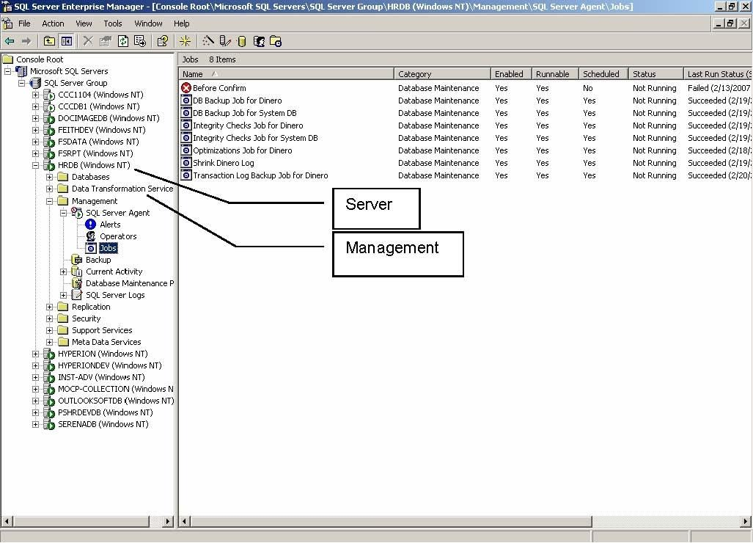 In **SQL Server Agent**, click +
6. Click *Jobs*

***View the Run Job Success***

All jobs are listed in the right pane

1. Verify that **Last Run Status** says “Succeeded”
2. Verify that **Next Run Date** is correct

If the **Last Run Status** was not successful, the Database Administrator researches the problem

1. Right click the job that failed
2. Select **View Job History**

**2-3. Create a New DB Maintenance Plan**

There will be 2 maintenance plans. These plans are oriented toward the college

1. SQL 2000 (interface like MMC; tree like with dialog boxes that pop up)
2. SQL 2005 (visual studio type interface)

Note: They are different because the interface is different.

1. Open SQL Enterprise Manager
2. Go to **SQL Server Group** and expand it
3. Select the server you want to build a plan for and expand it
4. Select management section and expand it
5. Select database maintenance plans
6. Right click database maintenance plans
7. Select *New Maintenance plan*

A maintenance plan wizard will open up. You want to set up for system databases.

**Database Maintenance Plan Wizard**

1. Select all system databases
2. When done, click **Next**

**Data Optimization Window**

1. Do nothing
2. Click **Next**

**Database Integrity Check Window**

1. Select **Check Database Integrity**
2. Select **Include Indexes Selection**
3. Leave other checkboxes blank
4. Click **Change** to change the schedule
5. Select **Daily**
6. Change the time to **10:00 p.m.**
7. Click **OK**
8. Click **Next**
9. Check **(√)** **Check Box**
10. Select **Daily (it should already be selected)**
11. Change the time to **10:05**
12. Click **Ok**
13. Click **Next**
14. Check **(√)** **Check Box**
15. Leave radio button on for **Default Backup Directory**
16. Check **(√)** to **Create** **A** **Subdirectory For Each Database**
17. Check **(√)** to **Remove Old Files**
18. Change **Remove Old** to be older than **4** days
19. Do not create a **Transaction Log Backup**

**Reports to Generate**

1. Check **(√)** to **Write Report**
2. Check **(√)** to **Delete Old Files**
3. Change to **4** days
4. Click **Next**
5. Leave **Maintenance Plan History** as is; do not change
6. When finished, give the plan a name (Usually **systemdb)**
7. Click **Finish**

IT creates a number of jobs for SQL Server Agent, the plan and jobs are linked together. The Database Administrator cannot go into one of the jobs and edit without alternating the plan, risking problems.

**2-4. Create a New Database**

1. Open SQL Server Enterprise Manager
2. Open the server on which you want to create the new database
3. Expand the database branch underneath (highlight database branch)
4. Click **(√)** New Database icon in the toolbar menu
5. Enter the database name
6. Click the **Data Files** tab
7. Enter the appropriate information
8. Set the initial size (this depends on the specs provided to the Database Administrator)

The initial size should be a little bigger than what the user needs. Once the Database Administrator decides how much larger to size the database, he estimates what a good size database will function properly.

1. Click **Transaction Log** tab
2. Set the initial size of the transaction log
3. Click the **General** tab

If the collation sequence for the database is not the same as the server default, the user must set it to select a a different server.

1. Click **OkSample of a Create Database code**

NOTE: If the database is large (great than 100 MB), the Database Administrator implements a SQL code to schedule a job to run in the background. If he doesn’t the implement this method, the creation process takes up to an hour. See sample code below.

Any kind of edits to jobs that were created with the maintenance plan must be performed through the maintenance plan.

CREATE DATABASE [HTST]

ON (NAME = N'DINERO_Data', FILENAME = N'H:\MSSQL\Data\HTST.mdf' , SIZE = 15256, FILEGROWTH = 256)

LOG ON (NAME = N'DINERO_Log', FILENAME = N'F:\MSSQL\Data\HTST_log.ldf' , SIZE = 16, FILEGROWTH = 16) COLLATE Latin1_General_BIN GO

**2-5. Register a SQL Server in Enterprise**

Registering a SQL Server in Enterprise allows the Database Administrator to run SQL server Enterprise Manager from the workstation to manage the database from a single screen.

1. Open SQL Server Enterprise Manager
2. Click on **Register Server Icon** (toolbar menu)
3. Type server name in **Properties** window
4. Uncheck **Automatically Start SQL Server When Connecting**
5. Click **Ok**

**2-6. Transfer Scanned Documents**

Create a New Vortex Configuration File to transfer scanned documents

1. Log into **DocimageDB server**
2. Model the new configuration file from the one in the **D:\Feith\COLD directory** (*.cfg)
3. Start **Feith Systems/Vortex/Vortex Monitor**
4. Click **Get Vortex Configuration**

**Modify File associations**

1. Select an association to model
2. Click **Modify**

**Save Backup associations**

1. Copy each line item into a notepad document
2. Click Cancel
3. Click Add

**Add File Associations**

1. Enter the new file association and paste in the saved line items appropriately
2. Modify the line items JobExec and JobCfg to use the proper association file name
3. Click **Add** when finished

**2-7. OutlookSoft: Set the System to Available**

Daily Verification of DTS Packages

The Database Administrator performs this procedure to make the OutlookSoft system available to the Accounting department to view reports.

1. Click **OutlookSoft Administration**

2. Click **Manage Dimensions**

A window called **Process dimensions** opens.

1. Select Application in **Select by**
2. Check (√) **Take System Offline**
3. Check (√) **Process Members from member sheet**
4. Check (√) **Full Process**
5. **OK**
6. Click **OK**, when **Progress** indicates *Successfully Finished*
7. Double Click **CCC** to condense the list
8. Select **Available**
9. Click **Update application set status**

**2-8. Recover Vortex Batches**

What to do when \docimagedb\scan\ has not emptied out its document images

1. Log in (2 ways):

* **DOCIMAGEDB** server, or
* Reference \\docimagedb\d$.

1. Navigate to the \Feith\Vortex\work\wrk001 directory on D: drive.
2. Open the **jobexec.log** file.
3. Scroll near the bottom of the log and look for the line doc_add_page() failed.

Above this line, see a list of values. The fourth value in the list is the last name of the applicant.

1. Open the **Export.adm** file.
2. Find all occurrences of the last name and their associated document image files.
3. Move all document image files associated with that name from *\docimagedb\scan* to \Feith\Vortex\Temphold. Copy **Export.adm** from \Feith\Vortex\work\wrk001 to \Feith\Vortex\Temphold.
4. Edit the copy of **Export.adm** that is still in \Feith\Vortex\work\wrk001 and remove the lines associated with the files you moved to \Feith\Vortex\Temphold.
5. Exit from **jobexec.log** and **Export.adm**
6. Change the Windows Explorer focus off the \Feith\Vortex\work\wrk001 directory.
7. Launch the Vortex Job Monitor and click the **Recover Failed Jobs** button.
8. Highlight the batch to be recovered and click the **Recover Now** button.
9. Wait for the recovery to start.

In the Job Handler Messages, if the line *D:\Feith\Vortex\work\work001* does not appear, the job recovered successfully.

1. Return to \Feith\Vortex\Temphold and examine the document image file(s). If there are no blank pages in the document, recover it in a separate run (contact DB administrator).

If there are blank pages in a document, a graphics TIFF file viewer (e.g., Irfanview) can be used to delete the blank pages before resubmitting.

1. Edit the **Export.adm** in \Feith\Vortex\Temphold.
2. Remove all lines except for the references to the document image files that are also in \Feith\Vortex\Temphold.
3. Move the document image files and **Export.adm** from \Feith\Vortex\Temphold to \docimagedb\scan.
4. Wait for the job to start.

If the files are processed, they disappear from \docimagedb\scan.

Contact MSI if the files do not process to determine what might be wrong with the document images.